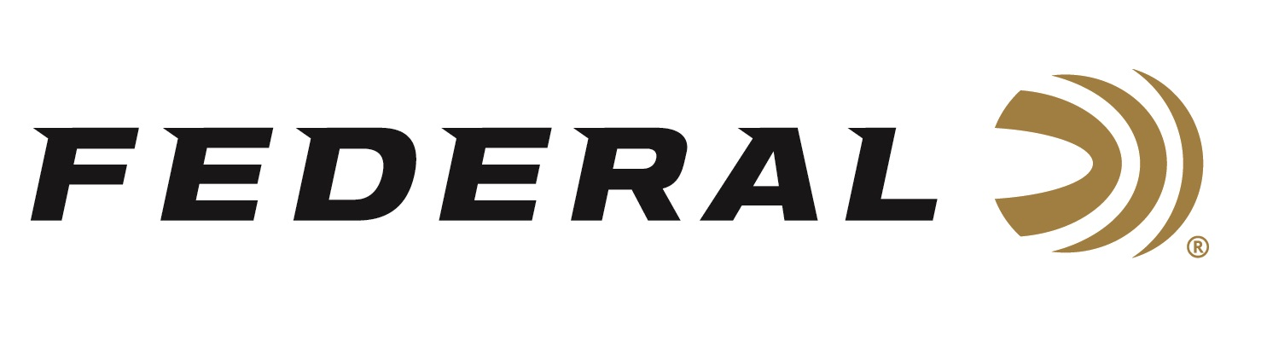

FOR IMMEDIATE RELEASE

MeatEater’s Steven Rinella and Janis Putelis join the “It’s Federal Season” Podcast

ANOKA, Minnesota – June 18, 2020 – Steven Rinella and Janis Putelis are familiar with podcasts. The dynamic duo has been producing the “The MeatEater Podcast” since January of 2015 and have released more than two-hundred twenty episodes. The “It’s Federal Season” podcast team catches up with Rinella and Putelis while on a South Dakota turkey hunt in the Black Hills near Rapid City.

Episode No. 9 - MeatEater Magic
https://www.federalpremium.com/podcast.html

“Rinella and Putelis bring the same level of energy, humor, and thoughtfulness into this conversation as they do with their own podcast,” said Jason Nash, Federal Ammunition’s Vice President of Marketing. “Steven is a great storyteller and he shares more about the beginnings of MeatEater, its purpose, and the core values of the growing lifestyle brand.”

In the Tech Talk segment, the MeatEater team stays on to talk about the relationship they have with Federal and its leading products including 3rd Degree, which both used to successfully harvest Merriam’s turkeys during their trip to South Dakota. Before signing off, find out what promotions are available for consumers to buy Federal products and merchandise. Rinella and Putelis highlight the current “Hunt Harder” promotion with MeatEater products from Federal and CCI and a free trial with onX. Look for more information at www.federalpremium.com or where you find your favorite podcasts.

Federal ammunition can be found at dealers nationwide or purchased online direct from Federal. For more information on all products from Federal or to shop online, visit www.federalpremium.com.

Press Release Contact: JJ Reich
Senior Manager – Press Relations
E-mail: VistaPressroom@VistaOutdoor.com

About Federal Ammunition
Federal, headquartered in Anoka, MN, is a brand of Vista Outdoor Inc., an outdoor sports and recreation company. From humble beginnings nestled among the lakes and woods of Minnesota, Federal Ammunition has evolved into one of the world's largest producers of sporting ammunition. Beginning in 1922, founding president, Charles L. Horn, paved the way for our success. Today, Federal carries on Horn's vision for quality products and service with the next generation of outdoorsmen and women. We maintain our position as experts in the science of ammunition production. Every day we manufacture products to enhance our customers' shooting experience while partnering with the conservation organizations that protect and support our outdoor heritage. We offer thousands of options in our Federal Premium and Federal® lines-it's what makes us the most complete ammunition company in the business and provides our customers with a choice no matter their pursuit.

